What Should You Do When…. A Pupil Gets Confused Between Simple and Compound Interest
I have often thought that maths classrooms should be as much places of theory testing and experimentation as any science lab. I had an opportunity to put this idea to the test recently when a pupil I was tutoring became confused between simple and compound interest. Admittedly, I ran this experiment online with a single individual using real money. However, it could easily be scaled up for a larger class, using play money instead of real.

Assumptions
Before running the experiment, the pupil should understand how to calculate the percentage of an amount and can do so comfortably using a division bar model, a calculator or whatever method they prefer. It is assumed that the pupil also has some experience of calculating simple and compound interest but that their understanding is insecure, and they are likely to make errors.

Aim of the Experiment
Explain to the pupil that they have £20. They are going to invest £10 in bank account A which offers a simple interest rate of 10% and £10 in bank account B which offers compound interest, also at a rate of 10%. The aim of the experiment is to find out which bank account earns them more money.

Hypothesis
Engage the pupil in an active discussion about which account – simple or compound interest – will earn them more money. Why? Ask the pupil to record this as a hypothesis.

Equipment Needed
The pupil will need two ten-pound notes. In addition, they will need a “bank” of money with which to pay the interest. This should include: £1 (ten), 20p (four), 10p (two), 5p (one) 2p (one) and 1p (three). This is enough money for five rounds of interest. The initial investment is kept small for practical reasons. This means that the difference between simple and compound interest will not be as great as when dealing with larger amounts of money. However, after the pupil grows more fluent in calculating the amount of money in a bank account after each interest round, a simulation can be run on Excel over further rounds of interest and with a larger initial investment. For the purposes of this experiment, the pupil can use a calculator as it is more important that they attend to the differences between simple and compound interest than they feel overwhelmed by the numbers.

Procedure
Tell the pupil: “On one side of your table, place a sign that says: ‘Account A: Simple Interest 10%’. On the other half, place a sign that says: ‘Account B: Compound Interest 10%’. Invest £10 in each bank account.”
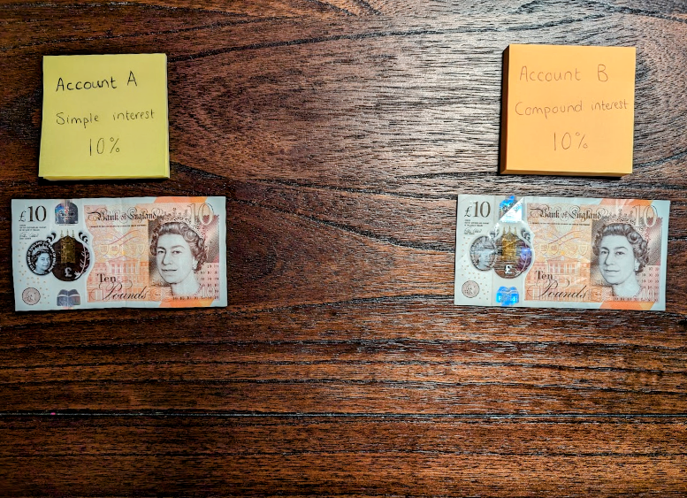
Figure 1. The pupil invests an initial sum of £10 in two bank accounts.
At this point the pupil should be given two ten-pound notes (real or play), one for each account. Explain that interest is calculated at the end of every month. How much interest is earned in account A at the end of the month? What about account B? Give the pupil two £1 coins interest and instruct them to add it to each account. Explain that this is the interest. Ask the pupil what they notice? Hopefully it is that at this stage, there is no difference between the two bank accounts and the method of calculating interest is the same. Get them to record their results in the table below.
 | Interest Round
 | 1 |  | 2 |  | 3 |  | 4 |  | 5
 | I | T | I | T | I | T | I | T | I | T
Account A
Account B
I = interest earned (£); T = total amount in bank account (£).
At the end of the second month, interest is calculated again. Ask the pupil how is the interest calculated in account A and account B? They may try to calculate 10% of the total amount in both bank accounts. Remind them that simple interest is interest that is calculated on the initial investment alone, whereas compound interest is interest that is calculated on the initial investment and any interest earned. Point to the money on the table when explaining this. Hopefully at this point the pupil will realise that they do not have to calculate simple interest again but add on £1, or the interest calculated previously. Give the pupil the interest earned (£1 in account A and £1.10 in account B) and get them to add it to each account. Tell the pupil to record the results in the table.
Repeat the same procedure for three more rounds of interest, by which point the pupil should feel comfortable that they do not have to calculate simple interest again, but they do need to recalculate compound interest at the end of every month. If they do not feel comfortable, continue until they do. (In this case you will need more money).

Results
Get the pupil to record their results on two graphs (see Figures 2 and 3). Give them graph paper on which the axes have already been drawn. Once again you want the pupil to attend to the difference between simple and compound interest rather than feel overwhelmed by trying to identify the correct scales on the graph. Once they have finished drawing the graphs, ask them what they notice?

Figure 2. Graph to show the amount of interest earned in two bank accounts after an initial investment of £10. Account A offered simple interest at a rate of 10%. Account B offered compound interest, also at a rate of 10%.

Figure 3. Graph to show the total amount of money in two bank accounts after an initial investment of £10. Account A offered simple interest at a rate of 10%. Account B offered compound interest, also at a rate of 10%.
Explain that initially the difference the two accounts is smalll. However, over time the differences will become larger. Simulate this on Excel. Ask if there is anything else that might cause the difference between the two accounts to become more apparent? Re-run the simulation with a larger initial investment. Plot a graph to show the results.

Conclusion
Ask the pupil to re-visit their initial hypothesis. Were they correct? Would they change it? Test for understanding by asking questions such as: what bank account would you chose when investing money? One that offers simple interest, or one that offers compound interest? What about when you borrow money from a bank? Would you want to take out a loan where you must repay the original amount plus simple interest or compound interest? Why?

